# Kafka and Zookeeper

## What is Kafka

Apache Kafka is a publish-subscribe messaging system. By saying that, we need to describe a messaging system. A messaging system lets you send messages between processes, applications, and servers.

Apache Kafka is a software where topics can be defined (think of a topic as a category) to where applications can add, process and **reprocess** data (messages).

Applications may connect to this system and transfer a message onto the topic. A message can include any kind of information.

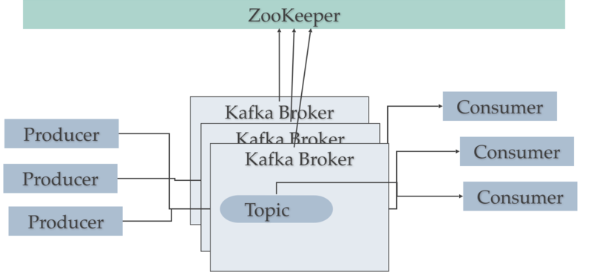

**Kafka Brokers**:

A Kafka cluster consists of one or more servers (Kafka brokers), which are running Kafka. Producers are processes that publish data (push messages) into Kafka topics within the broker. A consumer of topics pulls messages off a Kafka topic.

**Zookeeper**:

Apache ZooKeeper plays the very important role in system architecture as it works in the shadow of more exposed [Big Data](https://data-flair.training/blogs/what-is-big-data/) tools, as [Apache Spark](https://data-flair.training/blogs/apache-spark-for-beginners/) or Apache Kafka. In other words, Apache Zookeeper is a distributed, open-source configuration, synchronization service along with naming registry for distributed applications.

## Download and Install Zookeeper

1. Download and Install Zookeeper 3.4.14 and change the cfg/zoo.cfg file dataDir=D:/tmp/zookeeper
   1. Set the env for ZOOKEEPER_HOME =D:\Zookeeper3.4.14
   2. Set the Path = ZOOKEPER_HOME\bin in your environment.
   3. Start the zookeeper from command prompt type C:\Usman>zkserver
   4. It will generate the server details and at last **binding to port:0.0.0.0/0.0.0.0:2181**

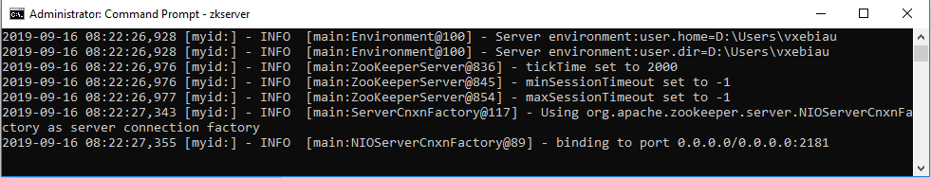

## Download and Install Kafka

1. Download and Install Kafka_2.12.x and change the config/server.properties file log.dir=D:/tmp/kafka-logs
   1. Set the Path=kafka\bin to your environment.
   2. Open command prompt and change it to the

COMMAND=D:\Farkalit\softwares\kafka_2.12-2.3.0\bin\windows>

* 1. Start the kafka server by typing on the command prompt

$ kafka-server-start.bat ..\..\config\server.properties

* 1. It will generate number of log statement then the last statement will be **“[KafkaServer id=0], started”**

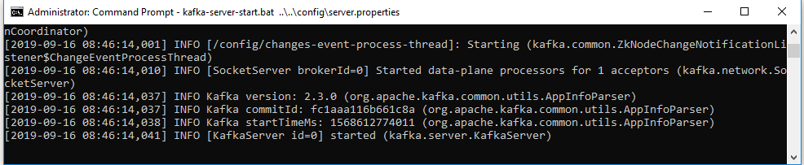

## Creating the Kafka Topic

1. It will create a topic named “**test**” w**ith single partition and one replica**.
   1. Open a new command prompt and set the bin/windows path as = D:\Farkalit\softwares\kafka_2.12-2.3.0\bin\windows
   2. Paste the following create command:

$ **kafka-topics.bat --create --bootstrap-server localhost:9092 --replication-factor 1 --partitions 1 --topic test**

* 1. You can view this created on topic with this command

$ kafka-topics.bat --list --bootstrap-server localhost:9092

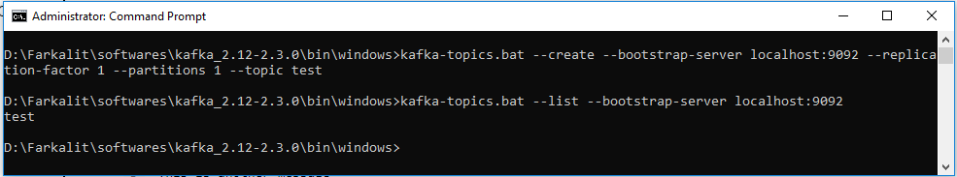

## Working with Kafka Topic send/consume

1. Working with Kafka Topic send/receive the messages.
   1. Open a new command prompt and set the bin/windows path as = D:\Farkalit\softwares\kafka_2.12-2.3.0\bin\windows
   2. Produce a message to the topic “test” with the following command:

$ **kafka-console-producer.bat --broker-list localhost:9092 --topic test**

* 1. It will open the producer command prompt as “>”. Type the message to send it.

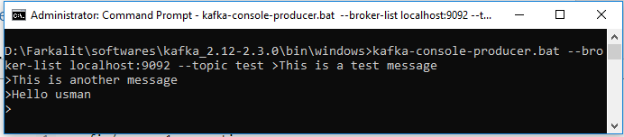

1. View the messages on the consumer side.
   1. Open a new command prompt and set the bin/windows path as = D:\Farkalit\softwares\kafka_2.12-2.3.0\bin\windows
   2. Type the following command to view the above messages:

$ **kafka-console-consumer.bat --bootstrap-server localhost:9092 --topic test --from-beginning**

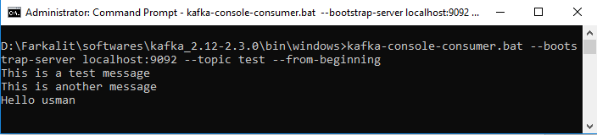

## Describe Topic details

1. Use the following command to know the detail information of the topic’s partition and replication etc.

$ **kafka-topics.bat --describe --topic test --zookeeper localhost:2181**

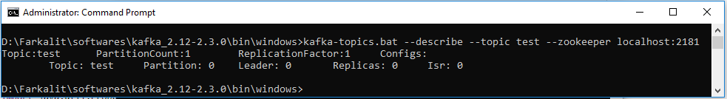

## Delete Kafka Topic

1. To delete a topic type the following command:

$kafka-run-class.bat kafka.admin.TopicCommand --delete –topic test --zookeeper localhost:2181

## Quick send resume message on Kafka topic

1. Start CMD prompt then change the directory location

CMD> cd **D:\Farkalit\softwares\kafka_2.12-2.3.0\bin\windows**

1. Start Zookeeper by CMD

**D:\Farkalit\softwares\kafka_2.12-2.3.0\bin\windows** >zkserver

1. Start the Kafka server by CMD

$**kafka-server-start.bat ..\..\config\server.properties**

1. Run Producer to send a message to the topic “test”:

$ **kafka-console-producer.bat --broker-list localhost:9092 --topic test**

1. Run Consumer to receive a messagein topic “test”

**$ kafka-console-consumer.bat --bootstrap-server localhost:9092 --topic test --from-beginning**

OR with IP Address: 10.7.91.40

$ kafka-console-producer.bat --broker-list 10.7.91.40:9092 --topic test

$kafka-console-consumer.bat --bootstrap-server 10.7.91.40:9092 --topic test --from-beginning

## Apache Kafka Topic on Linux:

* Login to Linux machine

$ cd kafka_2.12-2.3.0

* Start Zookeeper:

bin/zookeeper-server-start.sh config/zookeeper.properties

* Start Kafka Server :

bin/kafka-server-start.sh config/server.properties

* Create new topic “topic”

bin/kafka-topics.sh --create --bootstrap-server localhost:9092 --replication-factor 1 --partitions 1 --topic test

* List all the topics which are available

bin/kafka-topics.sh --list --bootstrap-server localhost:9092

* Run the producer with TOPIC name “test”

bin/kafka-console-producer.sh --broker-list localhost:9092 --topic test

* Run the consumer with TOPIC name “test”

bin/kafka-console-consumer.sh --bootstrap-server localhost:9092 --topic test --from-beginning

OR with IP Address: 10.1.131.136

bin/kafka-console-producer.sh --broker-list 10.1.131.136:9092 --topic test

bin/kafka-console-consumer.sh --bootstrap-server 10.1.131.136:9092 --topic test --from-beginning

## Java with Kafka topics

Create a java application to send messages in Kafka topic.

1. Add Kafka jar dependency in pom.xml
2. Add the Kafka configuration in application.properties file.
3. Create KafkaConsumer.java & KafkaProducer.java
4. The use the above classes in your controller/services as required.

# For Further Reading

1. Installation: <https://codenotfound.com/apache-kafka-download-installation.html>
2. Working with Kafka: <https://kafka.apache.org/quickstart>
3. For details: <https://dzone.com/articles/running-apache-kafka-on-windows-os>
4. Tool : <http://www.kafkatool.com/download.html>